**REVIEW – 1 & 2**

**INTRODUCTION:**

The poultry industry is a vital component of the global food supply chain. However, poultry diseases can have a significant impact on poultry production, leading to high mortality rates, decreased productivity, and significant economic losses. Early detection of diseases in poultry is therefore essential to ensure timely intervention and effective disease management.

The early disease prediction project in poultry aims to develop a system that can predict the occurrence of diseases in poultry flocks at an early stage using machine learning algorithms. This will improve the overall health and well-being of the birds, reduce mortality rates, and improve the efficiency of poultry farming.

The project involves collecting and analysing data from public dataset. Machine learning algorithms are then used to analyse the data and make predictions about the likelihood of a disease outbreak.

The system will be designed to alert farmers and other stakeholders in the poultry industry to potential disease outbreaks so that appropriate measures can be taken to prevent the spread of the disease. This could include implementing quarantine measures, adjusting feed and water systems, or administering treatments to infected birds.

The project will require collaboration between experts in poultry farming, data analysis, and machine learning to develop a comprehensive system that can accurately predict the occurrence of diseases in poultry flocks. The system has the potential to significantly improve the efficiency and profitability of poultry farming while also improving the health and well-being of the birds.

**PROBLEM STATEMENT:**

Early disease prediction in poultry with fecal images using deep learning is to develop an automated system that can accurately and efficiently detect and predict the onset of diseases in poultry using fecal images. The current methods of disease detection in poultry are time-consuming, labor-intensive, and often subjective, leading to delayed diagnoses and increased mortality rates.

The proposed system aims to address these issues by using deep learning algorithms to analyse fecal images and identify early signs of diseases. The system will be designed to detect multiple diseases and provide early warnings to farmers and veterinarians, enabling them to take timely and appropriate measures to prevent the spread of the disease and reduce mortality rates.

**LITERATURE SURVEY:**

|  |  |  |  |
| --- | --- | --- | --- |
| **TITLE** | **AUTHOR AND YEAR** | **METHODOLOGY** | **ACCURACY** |
| Poultry diseases diagnostics  models using deep learning | Dina Machuve, Ezinne Nwankw†, Neema Mduma and  Jimmy Mbelwa – 2021 | * This paper describes the development and testing of a deep learning model using various CNN architectures for detecting poultry diseases from fecal images. * The MobileNetV2 model was found to be the most promising for deployment on smartphones. * The study contributes a new dataset and suggests future work on object detection and training with farmers. | Baseline CNN – 83.06%  VGG16 – 85.85%  MobileNetV2 –  87.46%  Xception –  88.27% |
| Deep convolutional neural network based medical image classification for disease diagnosis | [Samir S. Yadav](https://link.springer.com/article/10.1186/s40537-019-0276-2#auth-Samir_S_-Yadav) &  [Shivajirao M. Jadhav](https://link.springer.com/article/10.1186/s40537-019-0276-2#auth-Shivajirao_M_-Jadhav) – 2016 | * This paper investigates the application of different image classification techniques, including transfer learning with VGG16 and InceptionV3, on a chest X-ray dataset to classify pneumonia. * Data augmentation is found to be effective in improving performance for all methods, while transfer learning is more effective than a support vector machine or capsule network. * Proper network complexity and retraining specific features are also important factors for improved performance. | 92% accuracy |
| Development of an early warning algorithm to detect sick broilers | Xiaolin Zhuang, Minna Bi , Jilei Guo, Siyu Wu, Tiemin Zhang – 2017 | * This paper proposes an approach to automatically classify healthy and sick broilers for early warning of poultry disease outbreaks. * Broiler images are segmented and posture features are extracted using machine learning algorithms. * The proposed algorithms show high accuracy and stability in identifying the health status of broilers and can provide early warning signals to prevent large-scale outbreaks of disease. | accuracy rates of 84.248% |

**DATASET DESCRIPTION:**

The annotated dataset of poultry disease diagnostics for small to medium-scale poultry farmers consists of poultry fecal images. The poultry fecal images were taken in Arusha and Kilimanjaro regions in Tanzania between September 2020 and February 2021 using Open Data Kit (ODK) app on mobile phones. The classes are "Coccidiosis”, “Healthy", "New Castle Disease”, “Salmonella". The images are resized to 224px by 224px.

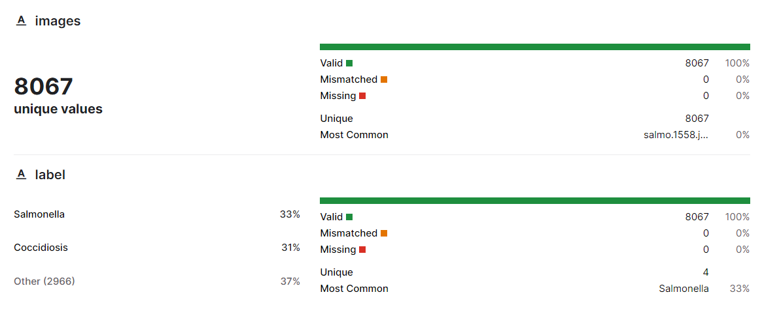

**Dataset Link:** <https://www.kaggle.com/datasets/allandclive/chicken-disease-1>

**IMPLEMENTATION SCREEN SHOTS:**

**Import Need Modules:**

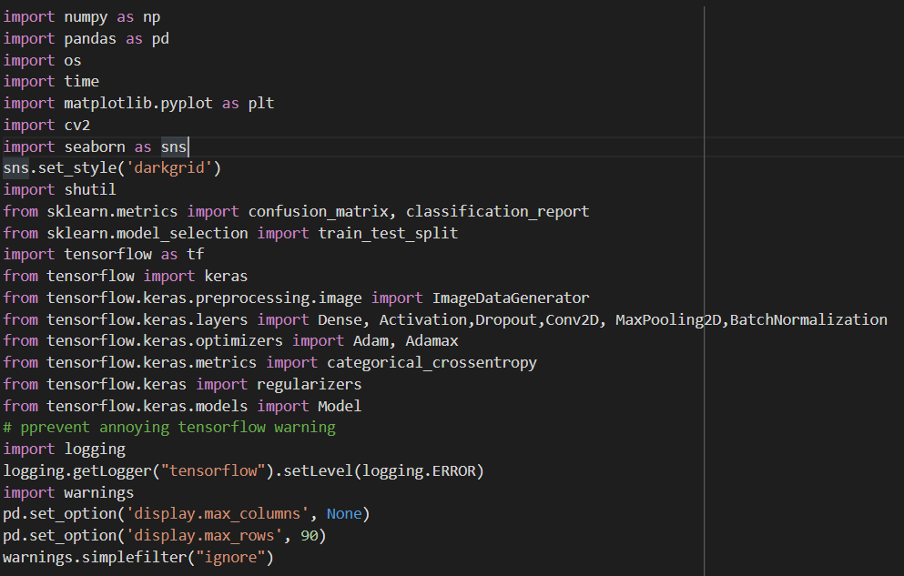

* This is a python script that imports various libraries for ML and computer vision tasks. This script uses these libraries to build, train, and evaluate a convolutional neural network (CNN) model for image classification.

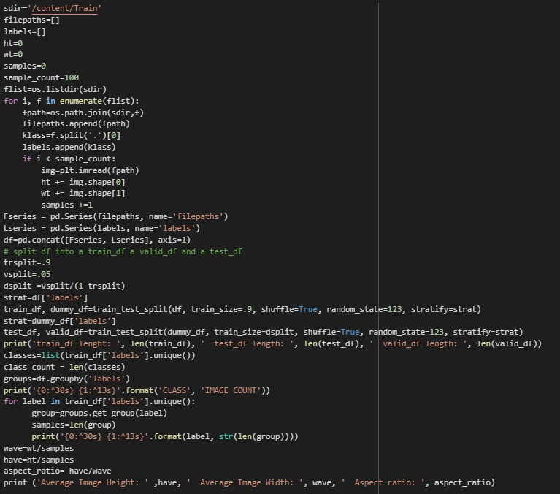

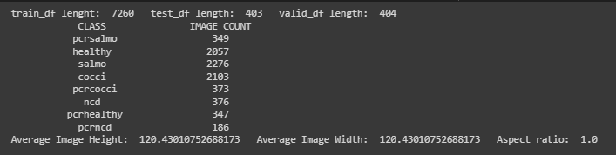

* This is a Python script for reading in and preprocessing a dataset of images for image classification. this code reads in an image dataset, creates a Pandas DataFrame of file paths and labels, splits it into train, validation, and test sets, and calculates some basic statistics about the images. The resulting train, validation, and test sets can be used for training and evaluating an image classification model.

**Trim the train_df data frame:**

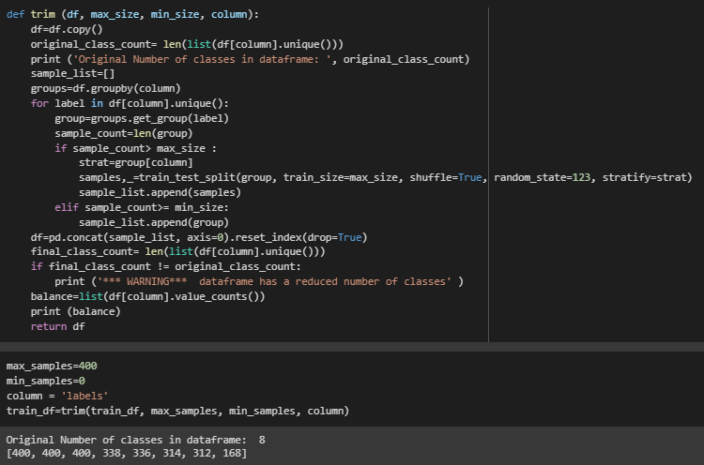

* This code defines a function named trim that takes in a pandas dataframe (df), a maximum sample size (max_size), a minimum sample size (min_size), and a column name (column). The function aims to balance the distribution of samples across the different classes in the column of the dataframe.

**Balance the train_df data frame**

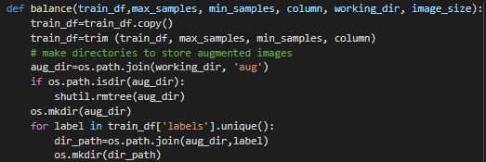

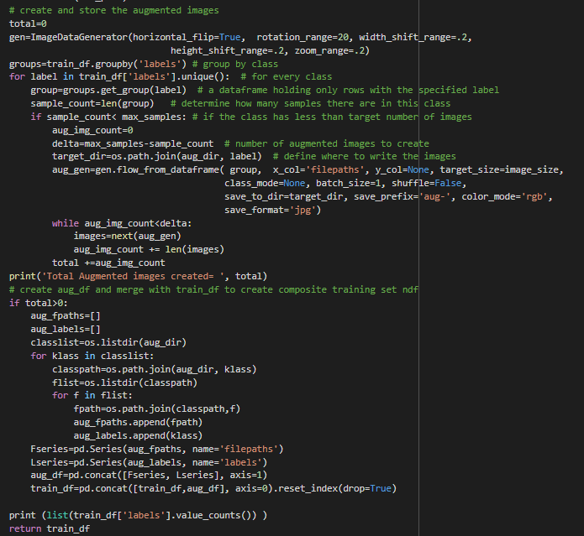

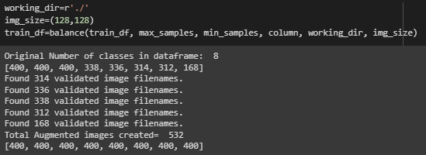

* This is a function that balances the class distribution in the training set by creating augmented images for underrepresented classes.

The function takes the following arguments:

* + **train_df**: A Pandas dataframe containing the training set with image file paths and labels.
  + **working_dir:** A string specifying the directory where the augmented images will be saved.
  + **image_size:** A tuple specifying the size of the augmented images.

**Create a function to show example training images:**

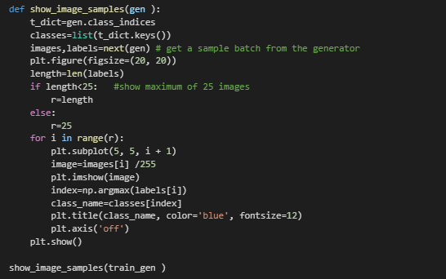

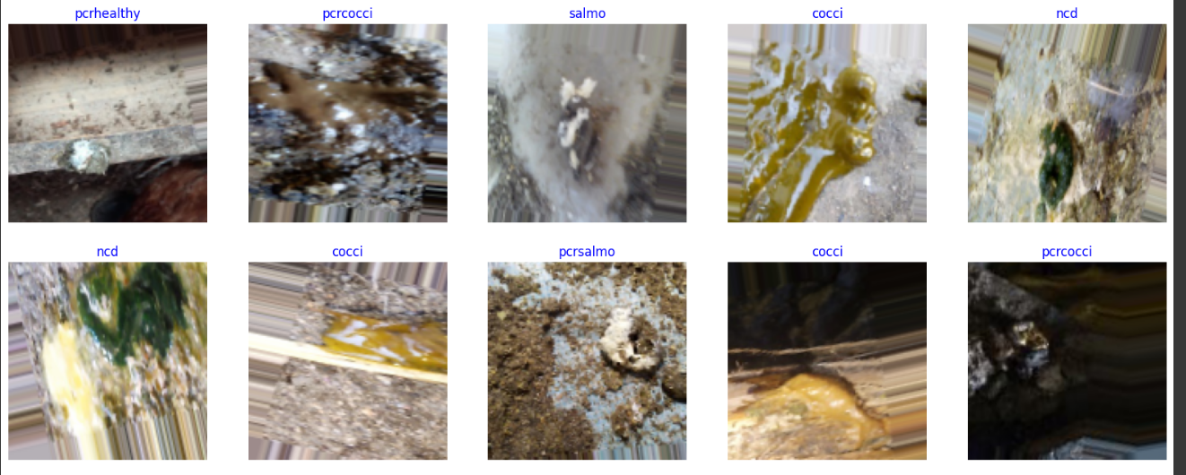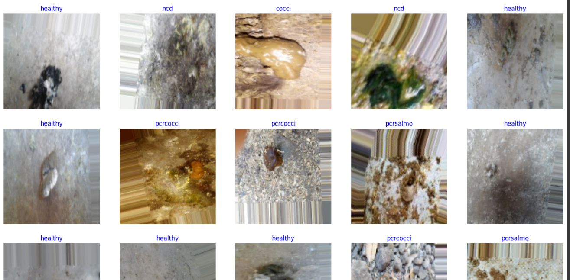

* In this code the function ‘show_image_sample’ that takes a generator(‘gen’) as its input. The generator is expected to provide batches of images and their corresponding labels.

**Create a model EfficientNetB3:**

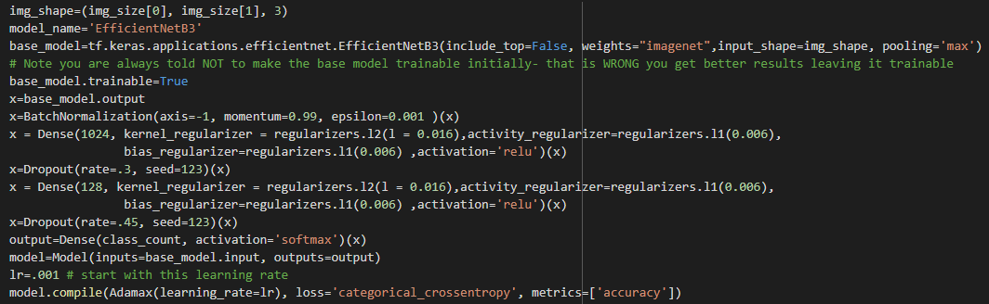

* This code defines a convolutional neural network using the EfficientNetB3 architecture for image classification. ‘base_model’ is set to the pre-trained EfficientNetB3 model without the top classification layer. It has been pre-trained on the ImageNet dataset, and the weights are initialized from that.

**Create a custom Keras callback to continue or halt training:**

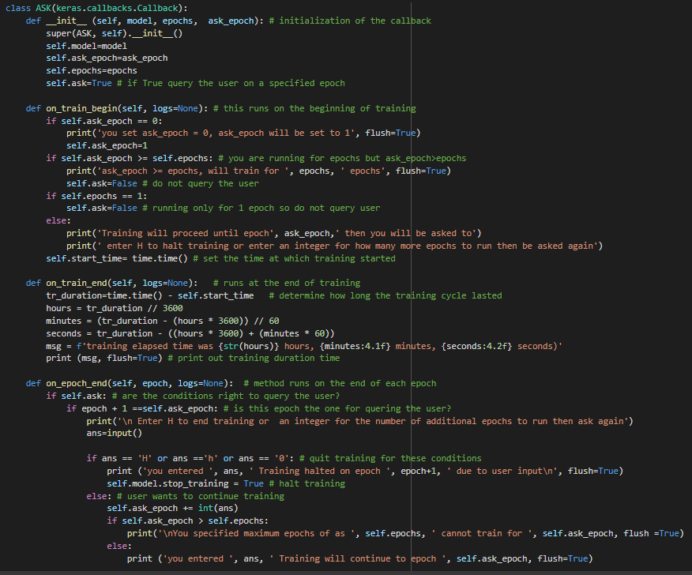



* This code defines a custom Keras callback class called ASK that asks the user if they want to continue training their model after a specified epoch. The purpose of this callback is to give the user more control over the training process, allowing them to halt training early or specify how many more epochs to run.

**Instantiate custom callback and create 2 callbacks to control learning rate and early stop:**

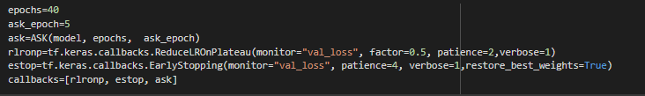

**Train the model:**

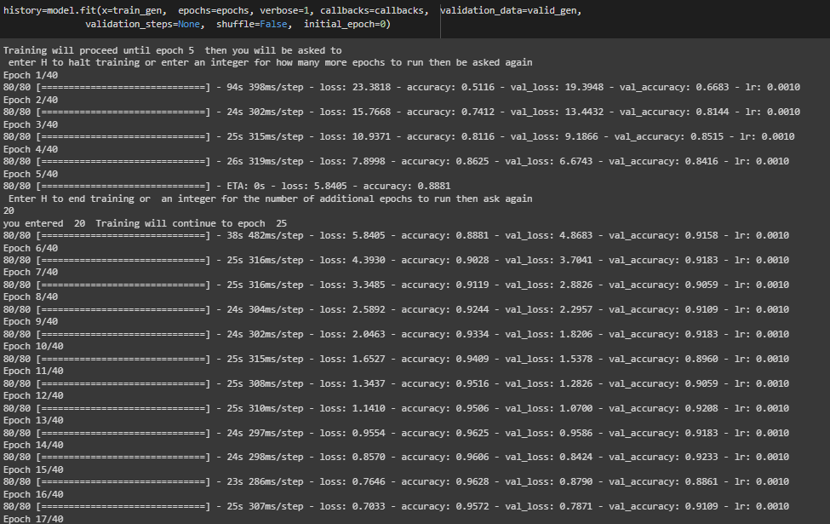

* This code is training the deep learning model using the fit method of the model object. The fit method returns a ‘history’ object that contains information about the training process, such as the loss and accuracy on the training and validation data at each epoch. In this code, the history variable is used to store this information.

**Define a function to plot the training data:**

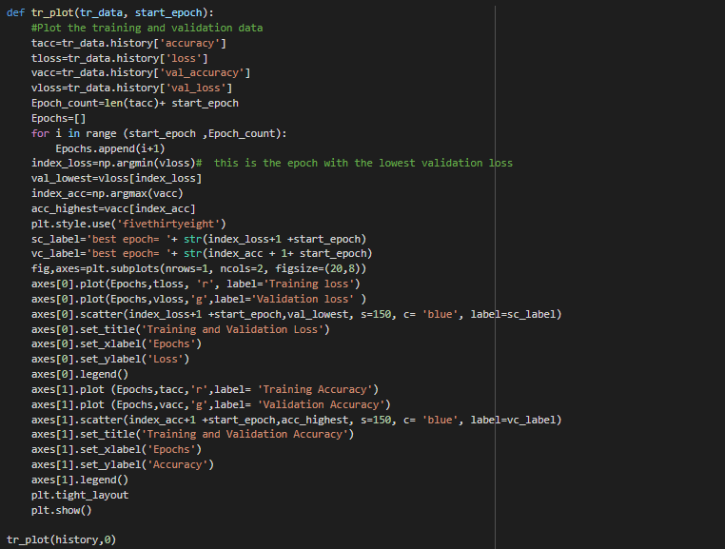

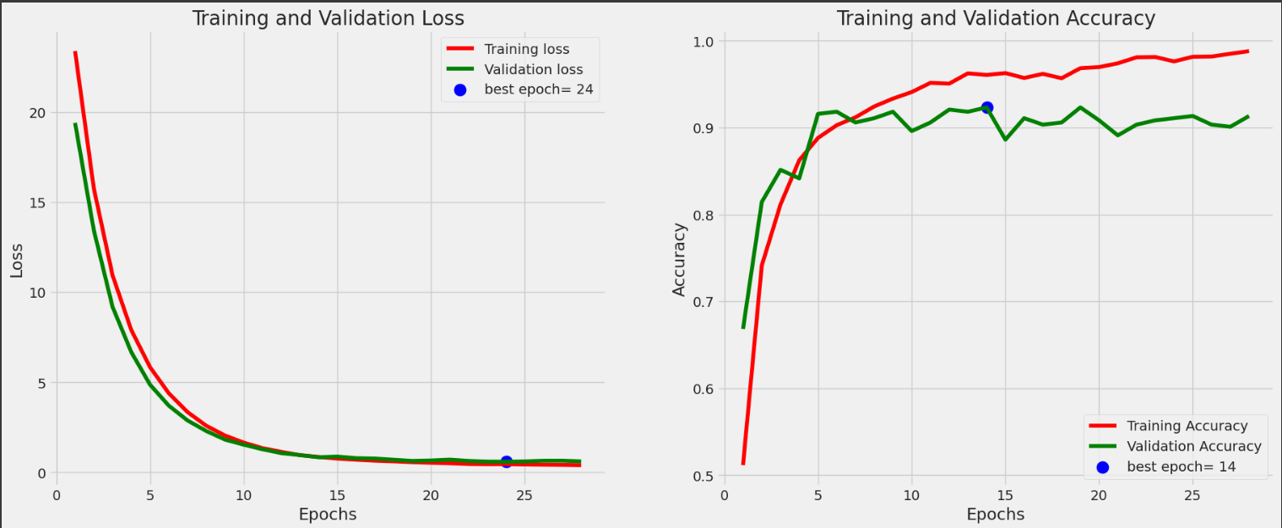

**Make predictions on test set, create Confusion Matrix and Classification Results:**

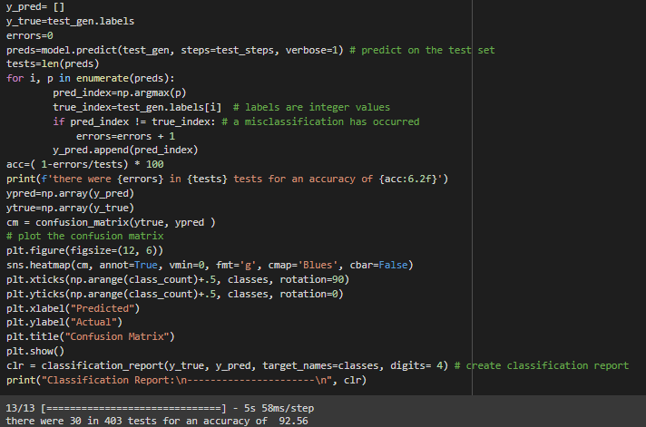

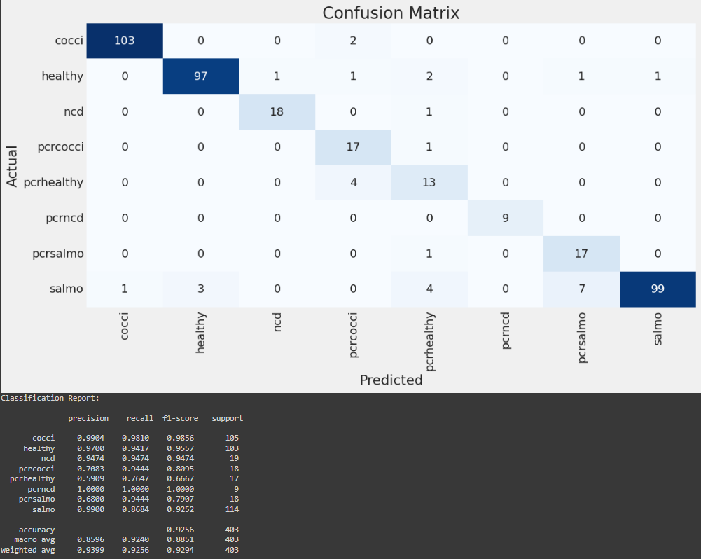

* This code computes the accuracy, confusion matrix, and classification
* report of a model on a test set.

**Save the model:**

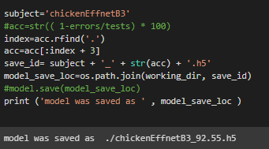

* This code saves the trained model with a file name based on the subject and the accuracy of **92.55%** achieved on the test set.

**REVIEW – 3**

**IMPROVEMENT MADE IN THE CODE:**

**Ensemble** is a technique in machine learning where two or more models are trained and combined to improve the overall performance and accuracy of the system.

In this we have trained three pre-trained models ***“EfficientNetB3, EfficientNetV2S, ResNet50V2”*** on the same dataset.

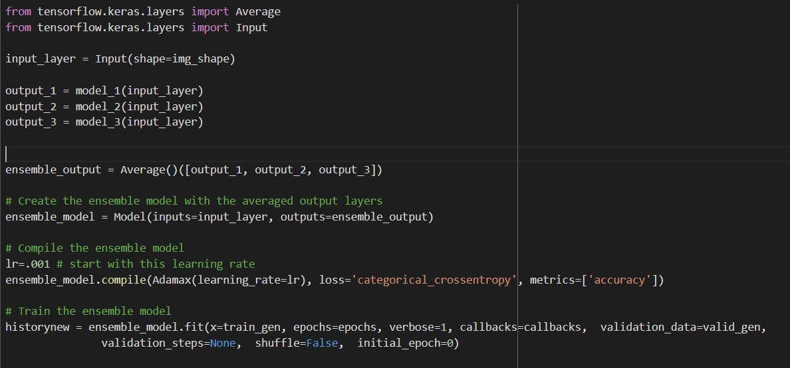

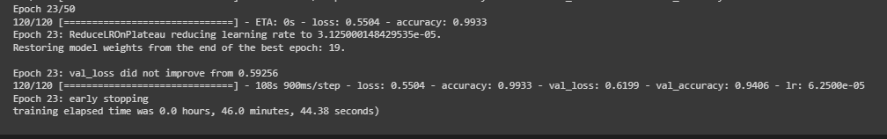

This code creates an ensemble model using three pre-trained models (model_1, model_2 and model_3) and averages their outputs to make predictions.

First, an input layer with the same shape as the base models is created. Then, the output layers of the base models are obtained by passing the input layer through each of them.

The output layers of the base models are then averaged using the Average() function, resulting in a single output layer for the ensemble model.

Finally, the ensemble model is trained using the training data (train_gen) and validation data (valid_gen) with a specified number of epochs, and the training progress is recorded in the historynew variable.

**Create a model EfficientNetB3(model_1), EfficientNetV2S(model_2), ResNet50V2(model_3):**

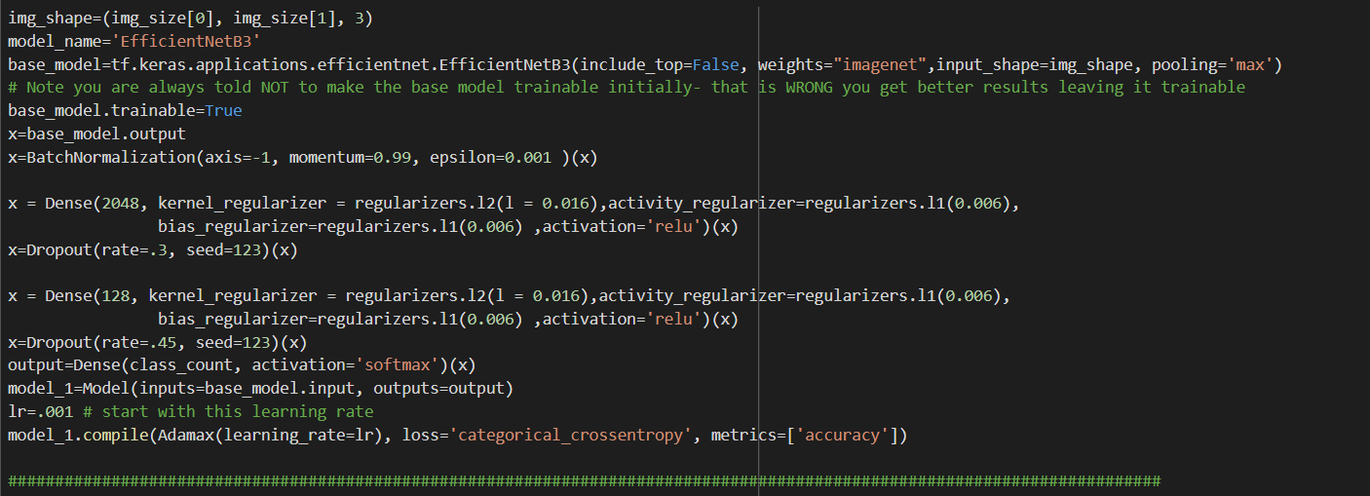 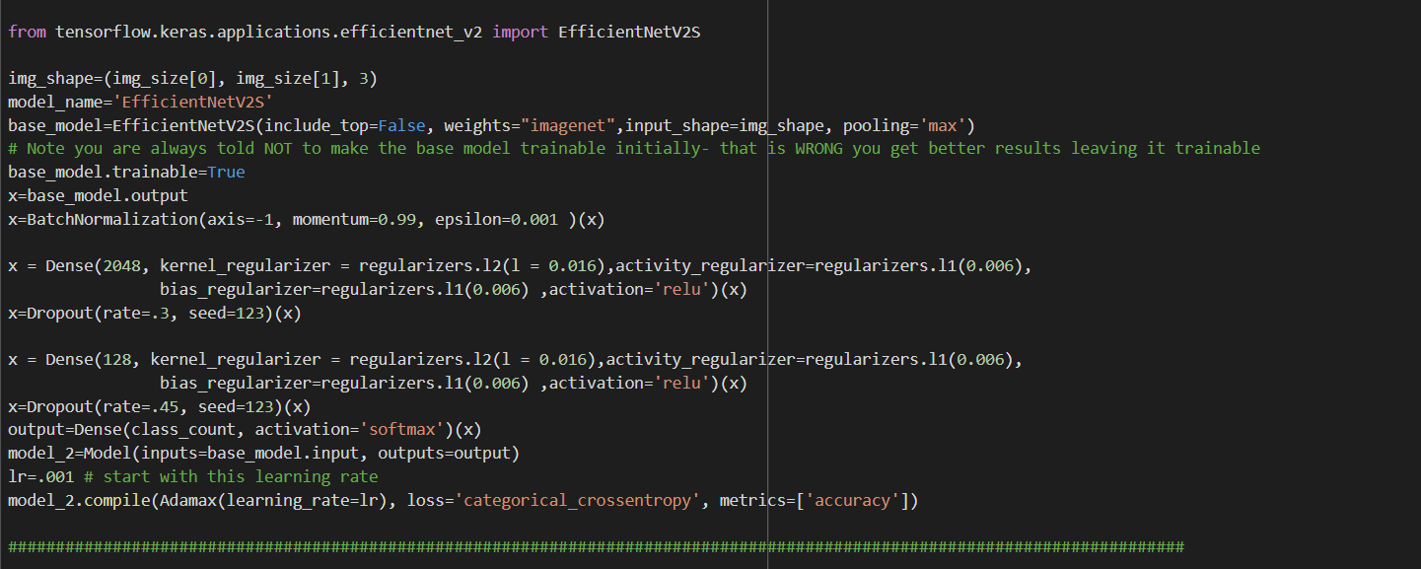 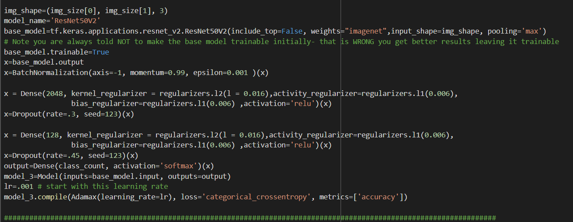

**Create a custom Keras callback to continue or halt training, Instantiate custom callback and create callbacks to control learning rate and early stop – for model_1:**

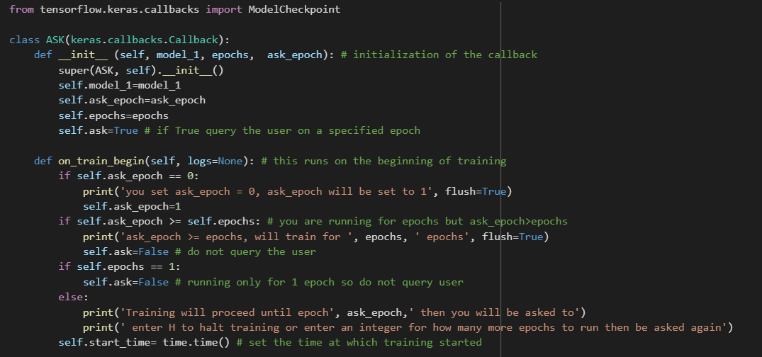 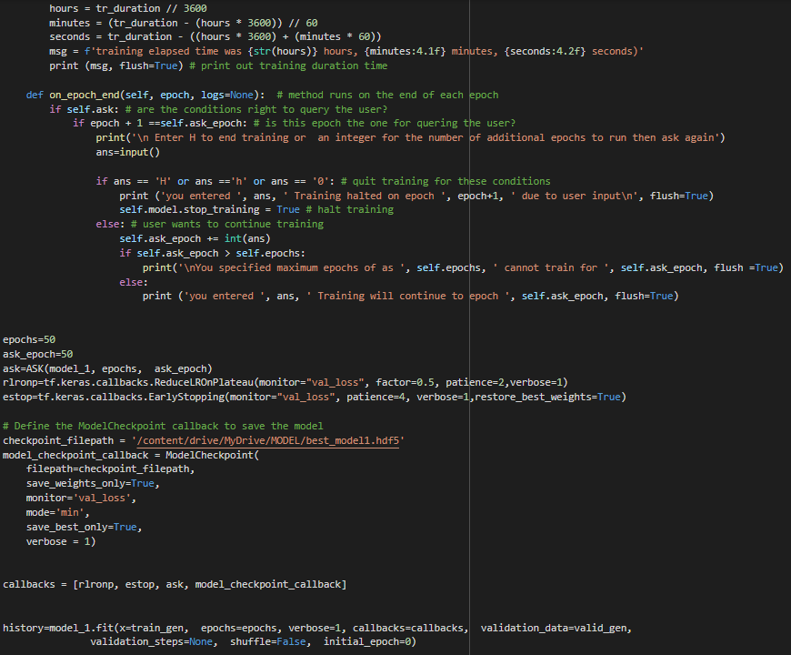

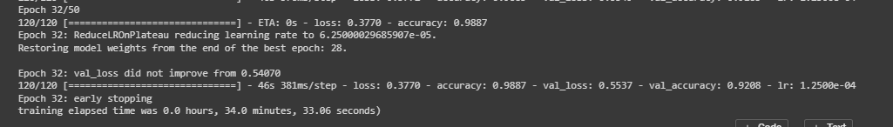

**Create a custom Keras callback to continue or halt training, Instantiate custom callback and create callbacks to control learning rate and early stop – for model_2:**

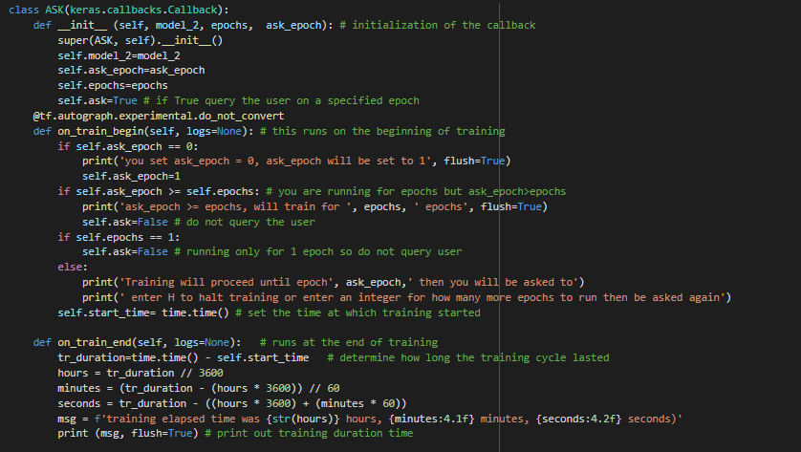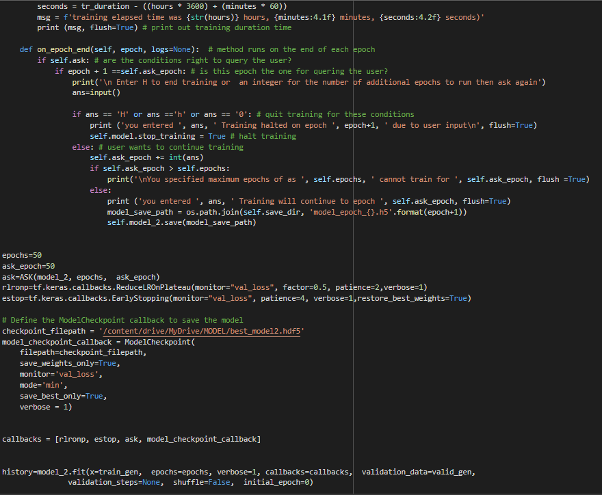



**Create a custom Keras callback to continue or halt training, Instantiate custom callback and create callbacks to control learning rate and early stop – for model_3:**

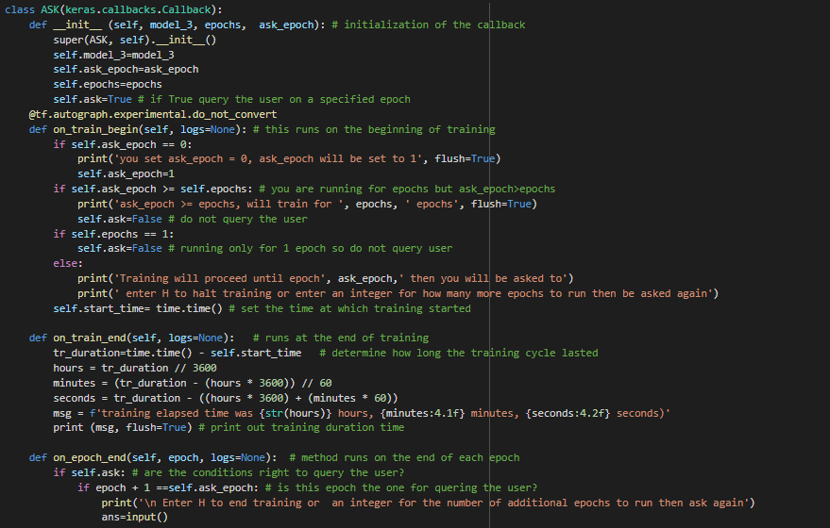 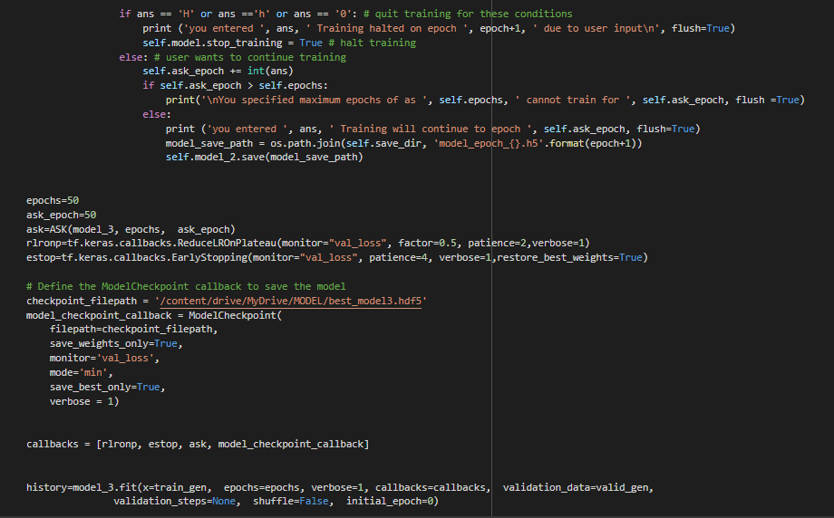 

**CONFUSION MATIX OF Ensemble_model:**

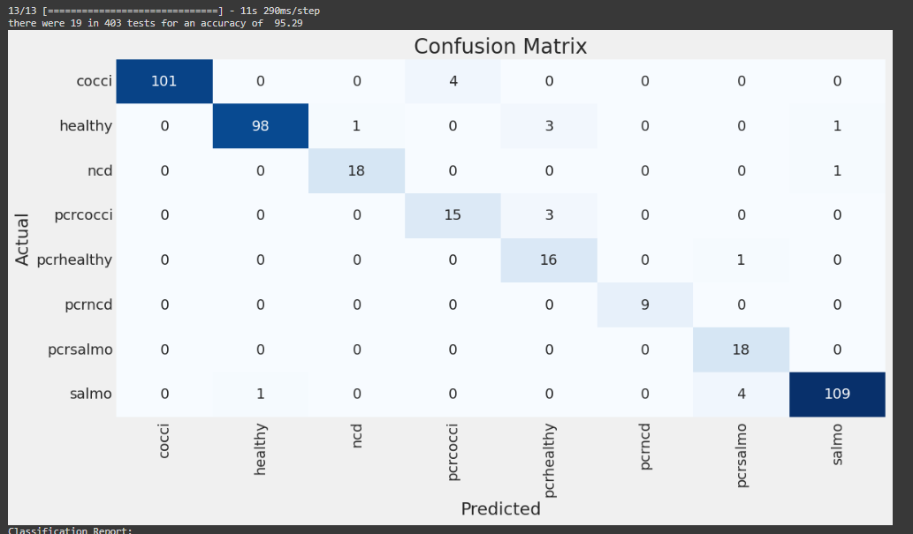

|  |  |
| --- | --- |
| **MODEL** | **ACCURACY** |
| EfficientNetB3 | 92.55% |
| EfficientNetV2S | 92.06% |
| ResNet50V2 | 91.81% |
| **ENSEMBLE_MODEL** | **95.29%** |

Hence, from the above table we can observe that the accuracy is improved using the ensemble technique.

**Colabnotebook link:** <https://colab.research.google.com/drive/1Uya2KzzXUWETFv9irbLp50PB57P3hNIH?usp=sharing>

**REFERENCE:**

1. Machuve, Dina & Nwankwo, Ezinne & Mduma, Neema & Mbelwa, Jimmy. (2022). Poultry diseases diagnostics models using deep learning. Frontiers in Artificial Intelligence. 5. 10.3389/frai.2022.733345.
2. Yadav, S.S., Jadhav, S.M. Deep convolutional neural network based medical image classification for disease diagnosis. J Big Data 6, 113 (2019).
3. Zhuang, Xiaolin & Bi, Minna & Guo, Jilei & Wu, Siyu & Zhang, Tiemin. (2018). Development of an early warning algorithm to detect sick broilers. Computers and Electronics in Agriculture. 144. 102-113. 10.1016/j.compag.2017.11.032.
4. Aloysius, Neena & Madathilkulangara, Geetha. (2018). Image Classification Using an Ensemble-Based Deep CNN: Proceedings of the 5th ICACNI 2017, Volume 3. 10.1007/978-981-10-8633-5_44.
5. Mbelwa, Hope & Mbelwa, Jimmy & Machuve, Dina. (2021). Deep Convolutional Neural Network for Chicken Diseases Detection. International Journal of Advanced Computer Science and Applications. 12. 10.14569/IJACSA.2021.0120295.
6. Jintao Wang, Mingxia Shen, Longshen Liu, Yi Xu, Cedric Okinda, "Recognition and Classification of Broiler Droppings Based on Deep Convolutional Neural Network", Journal of Sensors, vol. 2019, Article ID 3823515, 10 pages, 2019.